OMODA & JAECOO are once again partnering with Poznań Game Arena, this time with the spectacular launch of the OMODA 4 model
The worlds of gaming and modern automotive are joining forces once again. OMODA & JAECOO are partnering with the anniversary edition of Poznań Game Arena! This year’s event will mark the next stage of this collaboration and will also serve as the venue for the OMODA 4’s first presentation in Poland, where it will be unveiled to the Polish public before its launch on the Polish market.

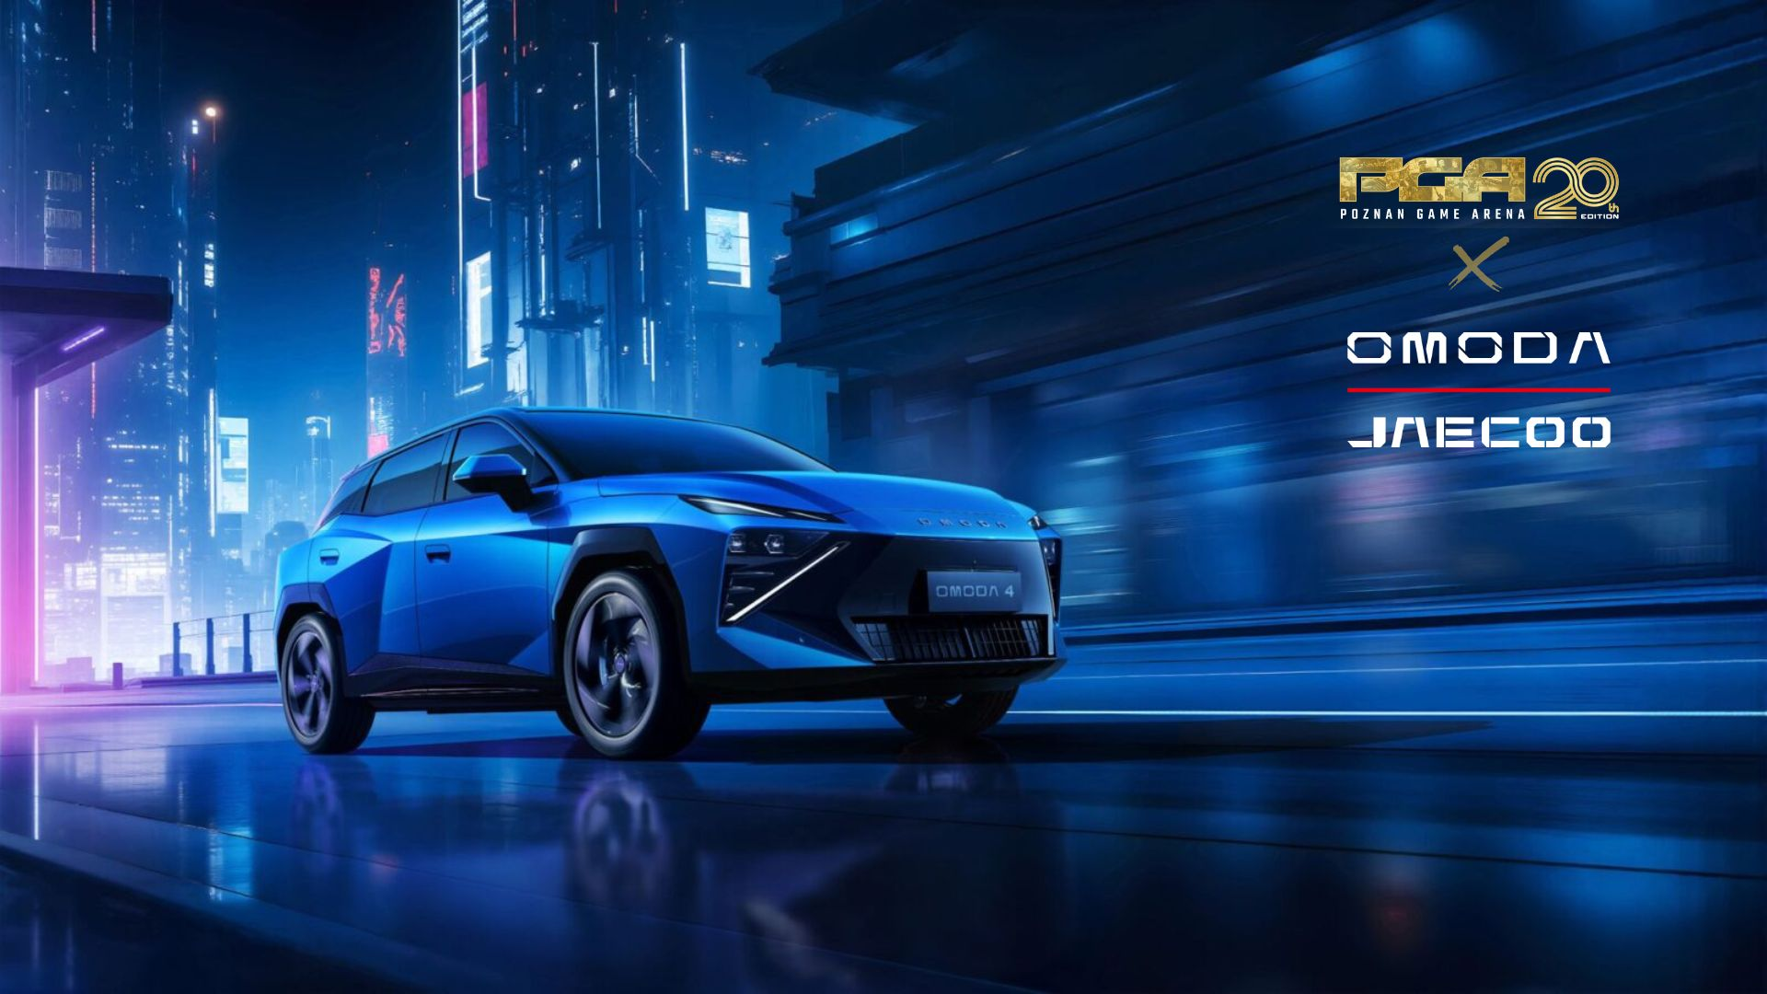

We have great news for all fans of new technologies, automotive, and gaming—OMODA & JAECOO is once again joining Poznań Game Arena as an event partner. Following last year’s exciting collaboration, the brand will once again be present at Poland’s largest gaming event, offering an extra dose of attractions for gamers, creators, and fans of technology and digital entertainment.
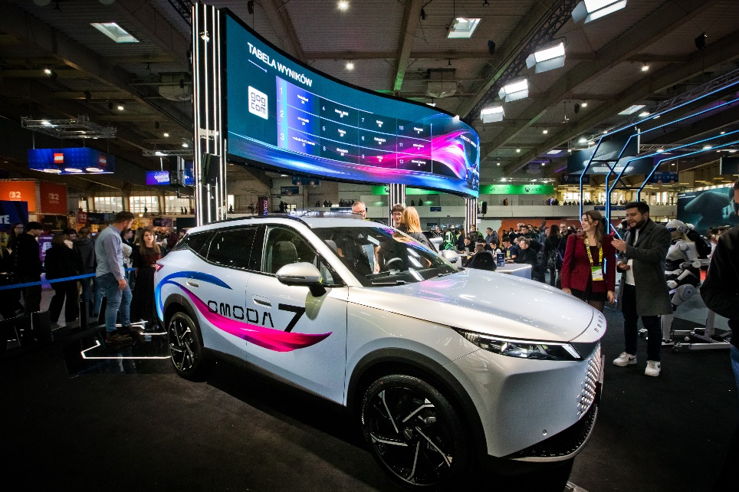

Gaming and the automotive industry? We’re already familiar with this duo!
The collaboration between OMODA & JAECOO and Poznań Game Arena is no coincidence. Already at PGA 2025, the brand demonstrated that modern automotive technology can be so much more than just a means of transportation. Last year’s appearance by OMODA & JAECOO was particularly special—it was during Poznań Game Arena that the OMODA 7 made its Polish debut.
Attendees had access to as many as 15 gaming stations, where they could compete in Quake III Arena for three days and, during breaks, return to the world of The Witcher 3: Wild Hunt. Test drives of OMODA and JAECOO cars were also available.
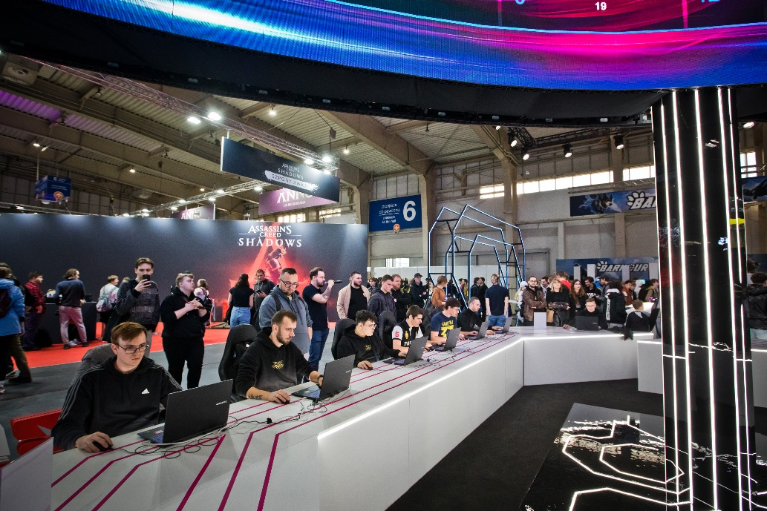
OMODA & JAECOO Returns to PGA with Another Major LaunchThe brand’s return to the Poznań Game Arena is a natural continuation of last year’s collaboration. OMODA & JAECOO is consistently expanding its presence on the Polish market, focusing on modern technologies, individuality, and solutions that meet the needs of a new generation of drivers.
This time, the OMODA 4 model will make its debut at Poznań Game Arena; it had its European premiere in late August during the VCT EMEA Finals in Barcelona. The European debut of the new model took place as part of OMODA’s partnership with VCT EMEA, in which the brand serves as a Global Partner and Official Automotive Partner. A special edition of the OMODA 4, created in collaboration with VALORANT, was also unveiled at the event.
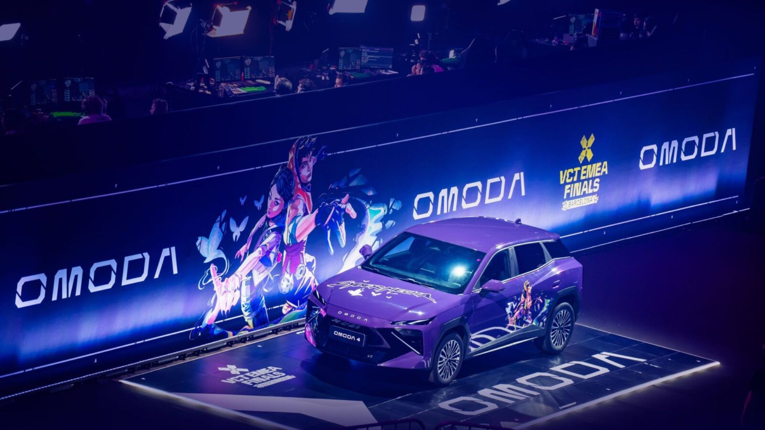
OMODA 4 – Geometric Design and Refined AerodynamicsThe OMODA 4 features a body with geometric surfaces, sharp lines, and clearly defined edges. The front of the car includes split headlights and linear daytime running lights. Their design creates a distinctive, symmetrical lighting layout. The taillights use similar, angular lines, ensuring a consistent design between the front and rear of the car. The body design was also developed with aerodynamic properties in mind. The streamlined construction resulted in a drag coefficient of 0.292 Cd.

OMODA 4 – AI Cockpit, Technology, and FunctionalityThe upcoming OMODA 4 will feature a comprehensive suite of onboard technologies. The smart cockpit will include an 8.88-inch full-LCD digital instrument cluster and a 13.2-inch HD screen. The car will also be equipped with a 540° Surround-View Camera System, providing the driver with a wide view of the vehicle’s surroundings. Other features will include 50 W wireless smartphone charging and a pop-up start button. One component of the onboard system will be an AI voice assistant based on a large language model, utilizing the architecture of an intelligent ecosystem that operates across various scenarios. The solution is designed to enable communication with the car using natural commands and to take into account the user’s intentions, habits, and preferences.

See you at Poznań Game Arena 2026—October 23–25 at the MTP Poznań Expo!

OMODA & JAECOO—welcome back to PGA!

